PHYTOTHERAPY

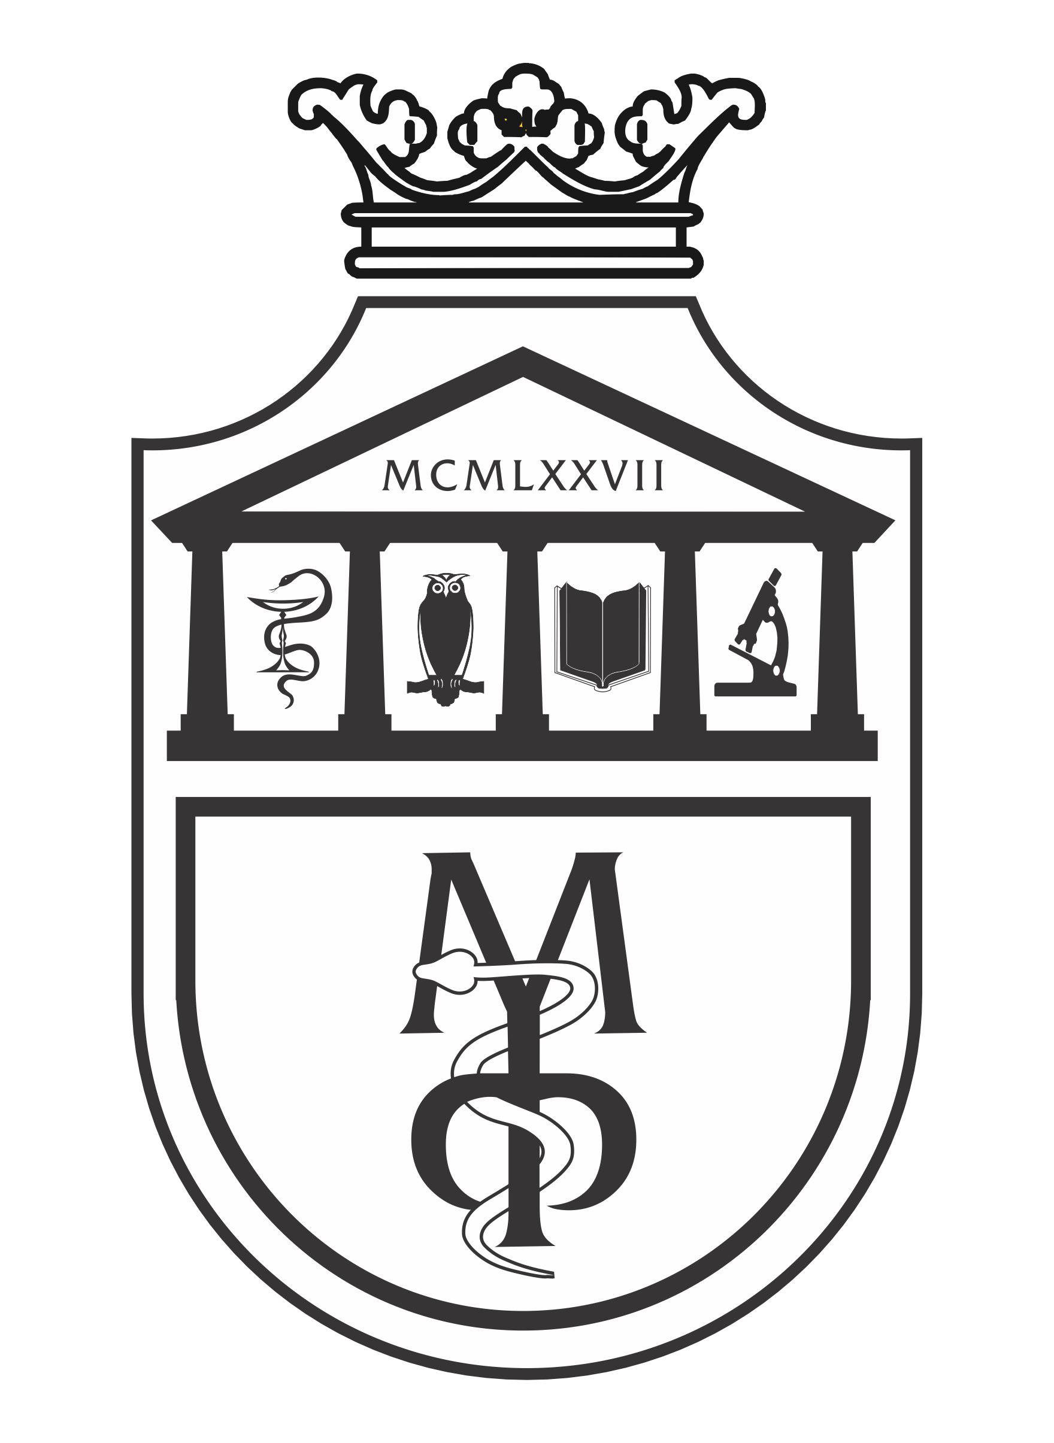

Pharmacy - Integrated academic studies

FOURTH YEAR- Semester VII

2025/26 School Year

Name of the course:

PHYTOTHERAPY

ECTS credits - 6; No. of hours active teaching per week: 4 (Lectures-3, Practice-1)

Teachers and instructors:

 | Name and surname | E-mail address | Academic rank
1. | Miroslav Sovrlić | sofke-ph@hotmail.com | Associate professor
2. | Jovica Tomović | jovicatomovic2011@gmail.com | Assistant professor
3. | Aleksandar Kočović | salekkg91@gmail.com | Assistant professor

Course structure:

Course contents | Weeks | Lectures | Practice | Course Coordinator
Rational phytotherapy; Pharmacologically active plant substances; Production, quality control, efficacy and safety of herbal medicinal products; European monographs; Pharmacological evaluation of natural products for some therapeutic areas; Aromatherapy and apitherapy. | 15 | 3 | 1 | Assoc. Prof. Miroslav Sovrlić

Students' knowledge assessment:

Students' knowledge assessment goes on during the whole semester and it includes points gained for completing practice work and progress tests as well as for the final written exam. The points can be gained according to the following model:

 | Points
Pre-exam requirements | 60 points
Taking progress tests | 30 points
Doing practice work | 30 points
Exam requirements | 40 points
Written examination | 40 points

In order to pass the exam, the student must achieve more than 50 percent of the points in all forms of teaching.

Grades:

The student gains a final grade which describes the quality of his knowledge and the results achieved in the course. The interrelation between points and final grades is given in the following table:

Num. achieved points | Num. grade | Definition
0 – 50 | 5 | UNSATISFACTORY
51 – 60 | 6 | PASS
61 – 70 | 7 | SATISFACTORY
71 – 80 | 8 | GOOD
81 – 90 | 9 | VERY GOOD
91 – 100 | 10 | EXCELLENT

LITERATURE:

Textbook | Authors | Publisher | Availability in the library
Fundamentals of Pharmacognosy and Phytotherapy, 3rd Edition | Heinrich M, Barnes J, Prieto-Garcia J, Gibbons S, Williamson E. | Elsevier Science. 2018. | YES
Herbal medicine. 3rd Edition | Barnes J, L Anderson, Phillipson D. | London: Pharmaceutical Press. 2007. | YES
Stockley's Herbal Medicines Interactions: A Guide to the Interactions of Herbal Medicines, 2nd Edition | Williamson E, Driver S, Baxter K. | Macmillan Distribution. 2013. | YES
Handbook of Drug-Nutrient Interactions | Boullata J, Armenti V. | Humana Press. 2010 | YES

All lectures (PowerPoint presentations) are available on the website of the Faculty of Medical Science: www.medf.kg.ac.rs
PROGRAM

UNIT I (FIRST WEEK):

Lectures (3 classes)  Introduction to phytotherapy. Herbal medicinal products. Rational phytotherapy. | Practice (1 classes)  Botanical classification, identification, collection, and storage of medicinal plants.

UNIT II (SECOND WEEK):

Lectures (3 classes)  Phytochemicals and their pharmacology actions. | Practice (1 classes)  Herbal extraction methods. Herbal formulations.

UNIT III (THIRD WEEK):

Lectures (3 classes)  Production, quality control, efficacy and safety  of herbal medicinal products. | Practice (1 classes)  European monographs.

UNIT IV (FOURTH WEEK):

Lectures (3 classes)  Herbal medicinal products for diseases of the cardiovascular system. | Practice (1 classes)  Formulations and monographs of plants used in the treatment of cardiovascular diseases.

UNIT V (FIFTH WEEK):

Lectures (3 classes)  Herbal medicinal products for central nervous system disorders. | Practice (1 classes)  Formulations and monographs of plants used in the treatment of CNS disorders.

UNIT VI (SIXTH WEEK):

Lectures (3 classes)  Herbal medicinal products for gynecological and urinary system conditions. | Practice (1 classes)  Formulations and monographs of plants used in the treatment of urogenital diseases.

UNIT VII (SEVENTH WEEK):

Lectures (3 classes)  Herbal medicinal products for diseases of the respiratory system. | Practice (1 classes)  Formulations and monographs of plants used in the treatment of respiratory diseases.

UNIT VIII (EIGHT WEEK):

Lectures (3 classes)  Herbal medicinal products for digestive system disorders. | Practice (1 classes)  Formulations and monographs of plants used in the treatment of digestive system disorders.
UNIT IX (NINTH WEEK):

Lectures (3 classes)  Herbal medicinal products for improving metabolism  and products with hormonal action. | Practice (1 classes)  Discuss evidence-based herbal medicines used for weight loss.

UNIT X (TENTH WEEK):

Lectures (3 classes)  Herbal medicinal products for musculoskeletal system and skin conditions. | Practice (1 classes)  Formulations and monographs of plants used in the treatment of arthritis, osteoporosis, back pain, and wound healing.

UNIT XI (ELEVENTH WEEK):

Lectures (3 classes)  Antimicrobial and antioxidant natural drugs. | Practice (1 classes)  Tests for antioxidant and antimicrobial activity and their relevance to herbal medicinal products.

UNIT XII (TWELFTH WEEK):
Lectures (3 classes)  Immunomodulatory and anticancer herbal medicinal products. | Practice (1 classes)  Discuss evidence-based herbal medicines used for herbal anticancer drugs.

UNIT XIII (THIRTEENTH WEEK):
Lectures (3 classes)  Herb-drug interactions, contraindications, toxicity, and side effects. | Practice (1 classes)  Digital tools and resources of clinically significant interactions between herbal medicines and drugs.

UNIT XIV (FOURTEENTH WEEK):

Lectures (3 classes)  Aromatherapy and apitherapy. | Practice (1 classes)  Bee products and essential oils in pharmacy.

UNIT XV (FIFTEENTH WEEK):

Lectures (3 classes)  Endemic medicinal plants of Serbia: Phytochemical potential and therapeutic use | Practice (1 classes)  Identification and analysis of endemic medicinal plants of Serbia

LESSON SCHEDULE FOR THE COURSE FUNDAMENTALS OF PHYSICAL CHEMISTRY
Week | Date | Time | Location | Form | Course unit title | Teacher
1 |  |  |  | L | Introduction to phytotherapy. Herbal medicinal products. Rational phytotherapy. | Assoc. Prof. Miroslav Sovrlić
1 |  |  |  | P | Botanical classification, identification, collection, and storage of medicinal plants. | Asst. Prof. Aleksandar Kočović
2 |  |  |  | L | Phytochemicals and their pharmacology actions. | Assoc. Prof. Miroslav Sovrlić
2 |  |  |  | P | Herbal extraction methods. Herbal formulations. | Asst. Prof. Aleksandar Kočović
3 |  |  |  | L | Production, quality control, efficacy, and safety of herbal medicinal products. | Assoc. Prof. Miroslav Sovrlić
3 |  |  |  | P | European monographs. | Asst. Prof. Aleksandar Kočović
4 |  |  |  | L | Herbal medicinal products for diseases of the cardiovascular system. | Assoc. Prof. Miroslav Sovrlić
4 |  |  |  | P | Formulations and monographs of plants used in the treatment of cardiovascular diseases. | Asst. Prof. Aleksandar Kočović
5 |  |  |  | L | Herbal medicinal products for central nervous system disorders. | Assoc. Prof. Miroslav Sovrlić
5 |  |  |  | P | Formulations and monographs of plants used in the treatment of CNS disorders. | Asst. Prof. Aleksandar Kočović
6 |  |  |  | L | Herbal medicinal products for gynecological and urinary system conditions. | Assoc. Prof. Miroslav Sovrlić
6 |  |  |  | P | Formulations and monographs of plants used in the treatment of urogenital diseases. | Asst. Prof. Aleksandar Kočović
7 |  |  |  | L | Herbal medicinal products for diseases of the respiratory system. | Assoc. Prof. Miroslav Sovrlić
7 |  |  |  | P | Formulations and monographs of plants used in the treatment of respiratory diseases. | Asst. Prof. Aleksandar Kočović
PROGRESS TEST 1
8 |  |  |  | L | Herbal medicinal products for digestive system disorders. | Assoc. Prof. Miroslav Sovrlić
8 |  |  |  | P | Formulations and monographs of plants used in the treatment of digestive system disorders. | Asst. Prof. Aleksandar Kočović
9 |  |  |  | L | Herbal medicinal products for improving metabolism and products with hormonal action. | Assoc. Prof. Miroslav Sovrlić
9 |  |  |  | P | Discuss evidence-based herbal medicines used for weight loss. | Asst. Prof. Aleksandar Kočović
10 |  |  |  | L | Herbal medicinal products for musculoskeletal system and skin conditions. | Asst. Prof. Jovica Tomović
10 |  |  |  | P | Formulations and monographs of plants used in the treatment of arthritis, osteoporosis, back pain, and wound healing. | Asst. Prof. Aleksandar Kočović
11 |  |  |  | L | Antimicrobial and antioxidant natural drugs. | Asst. Prof. Jovica Tomović
11 |  |  |  | P | Tests for antioxidant and antimicrobial activity and their relevance to herbal medicinal products. | Asst. Prof. Aleksandar Kočović
12 |  |  |  | L | Immunomodulatory and anticancer herbal medicinal products. | Asst. Prof. Aleksandar Kočović
12 |  |  |  | P | Discuss evidence-based herbal medicines used for herbal anticancer drugs. | Asst. Prof. Aleksandar Kočović
13 |  |  |  | L | Herb-drug interactions, contraindications, toxicity, and side effects. | Asst. Prof. Jovica Tomović
13 |  |  |  | P | Digital tools and resources of clinically significant interactions between herbal medicines and drugs | Asst. Prof. Aleksandar Kočović
14 |  |  |  | L | Aromatherapy and apitherapy. | Asst. Prof. Jovica Tomović
14 |  |  |  | P | Bee products and essential oils in pharmacy. | Asst. Prof. Aleksandar Kočović
15 |  |  |  | L | Endemic medicinal plants of Serbia: Phytochemical potential and therapeutic use. | Asst. Prof. Aleksandar Kočović
15 |  |  |  | P | Identification and analysis of endemic medicinal plants of Serbia | Assoc. Prof. Miroslav Sovrlić
PROGRESS TEST 2
EXAM (January examination deadline)

